Name | R.Santhiya
Reg.no. | 621421106041
Department | ECE
Year | III
College Name | Maha Barathi Engineering college
Group | IOT_Flood Monitering And Early Warning

FLOOD MONITERING AND EARLY WARNING
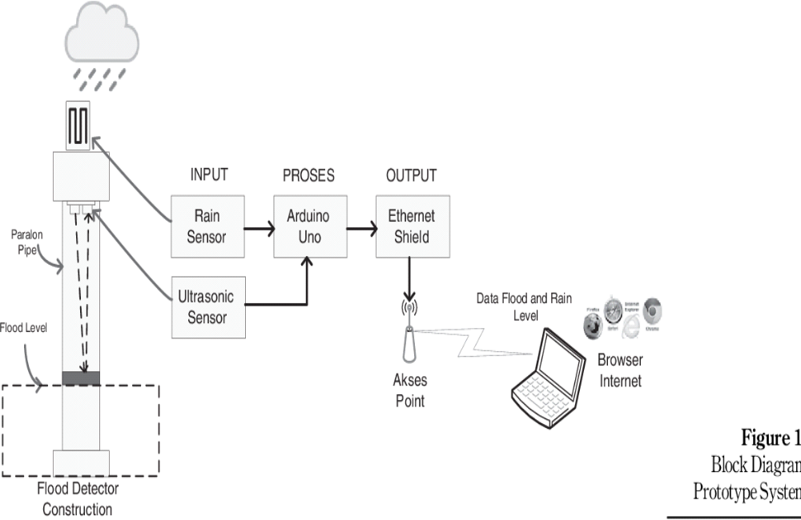

PARALON PIPE :
- Paralon is the name for uPVC pipe, while Pralon is a brand of uPVC pipe. Why is the uPVC pipe called a paralon? Because the Top of Main brand does affect all of the uPVC pipes. Pralon became the top of main brand for uPVC pipes and a well-known brand.
FLOOD DETECTOR AND CONSTRUCTION :
- Flooding detection system means a system of sensors and alarms that detect and warn of water ingress into watertight spaces. Continuous flood level monitoring may be provided, but is not required.
RAIN SENSOR :
- Rain sensors prevent this frustrating and wasteful occurrence. These devices are designed to temporarily shut off an irrigation system so it stops running when it detects rain. Rain sensors can be retrofitted on installed sprinkler systems. You may also see them referred to as rain shut-off devices or rain switches.
ULTRA SONIC SENSOR :
- An ultrasonic sensor is an instrument that measures the distance to an object using ultrasonic sound waves. An ultrasonic sensor uses a transducer to send and receive ultrasonic pulses that relay back information about an object's proximity.
ARDUINO UNO :
- Arduino UNO is a low-cost, flexible, and easy-to-use programmable open-source microcontroller board that can be integrated into a variety of electronic projects. This board can be interfaced with other Arduino boards, Arduino shields, Raspberry Pi boards and can control relays, LEDs, servos, and motors as an output.
ETHERNET SHIELD :
- The Arduino Ethernet Shield allows an Arduino board to connect to the internet. It is based on the Wiznet W5100/W5200 ethernet chip providing a network (IP) stack capable of both TCP and UDP. Use the Ethernet library to write sketches which connect to the internet via a RJ45 Ethernet jack.
ACCESS POINT :
- An access point is a device that creates a wireless local area network, or WLAN, usually in an office or large building. An access point connects to a wired router, switch, or hub via an Ethernet cable, and projects a Wi-Fi signal to a designated area.

